WPT Lab Documentation

* Wireless charging pad (WCP) preparation
  + The WCP must be removed from any housing it comes it, in the case of the one used the screws holding the housing together were taken out allowing the device to be opened and the actual wireless charging pad coil and control board to be revealed. Once the WCP is removed, solder two lead wires to the exposed coils to easily interface the oscilloscope with the coil and avoid connection issues disrupting readings. Figure 1 contains the WCP setup
* USB Data Capture
  + To capture data from the oscilloscope, use a USB-A that is placed into the port on the front face of the machine. The USB needs to be FAT32 formatted in order to capture images. To format the drive you can place into into a computer, right click on the drive and select format. In the format menu use the file system dropdown to select FAT32.
  + To save images from the oscilloscope the “Save” button will capture the device at the current specifications. To change what is captured use the “Save/Recall” button where you can select the format of the data saved (.png image, .isf waveform file, etc).
  + Current data capture appears limited to a single screenshot.

Images and Attachments

Figure 1: WCP exposed coil and soldered lead wires

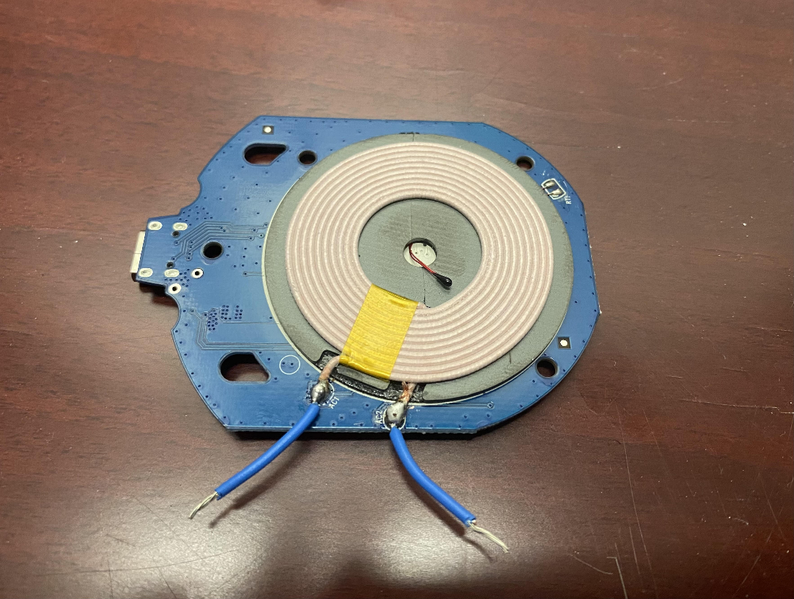

Figure 2: Waveform Generator settings to be used in experiment

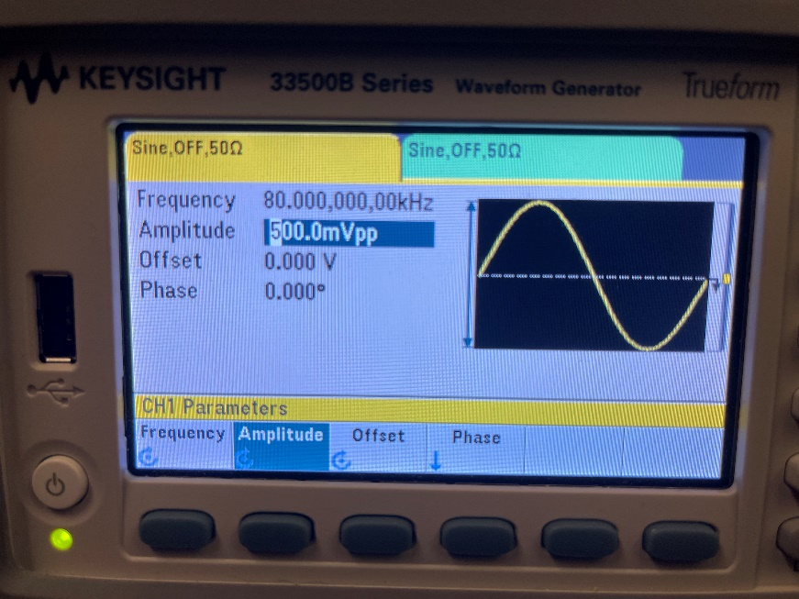

Figure 3: Data from Gao Experiment (which paper/source specifically?)

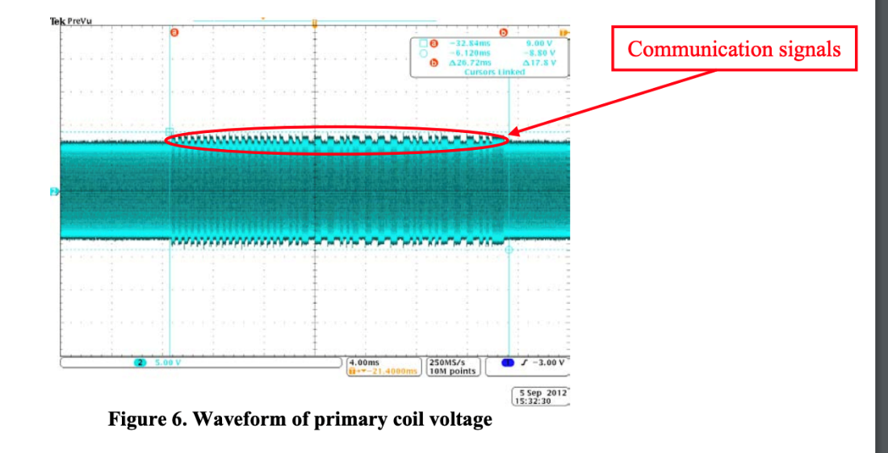

Figure 4: Setup to read signal through adversarial coil

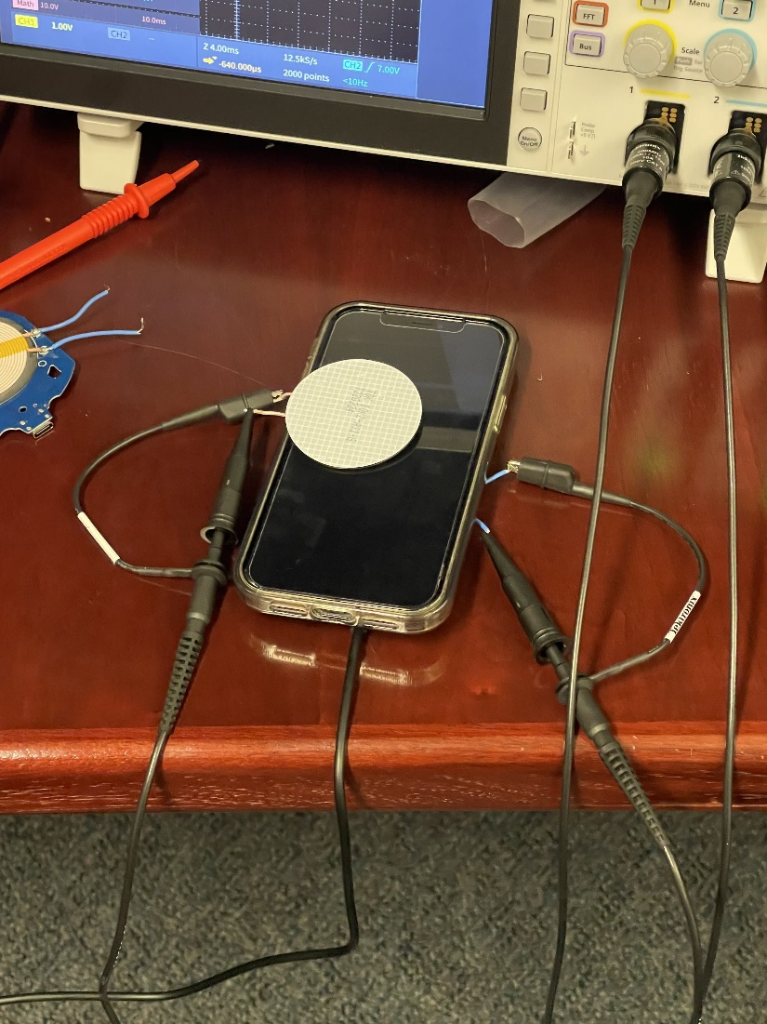

Figure 5: Reading through adversarial coil

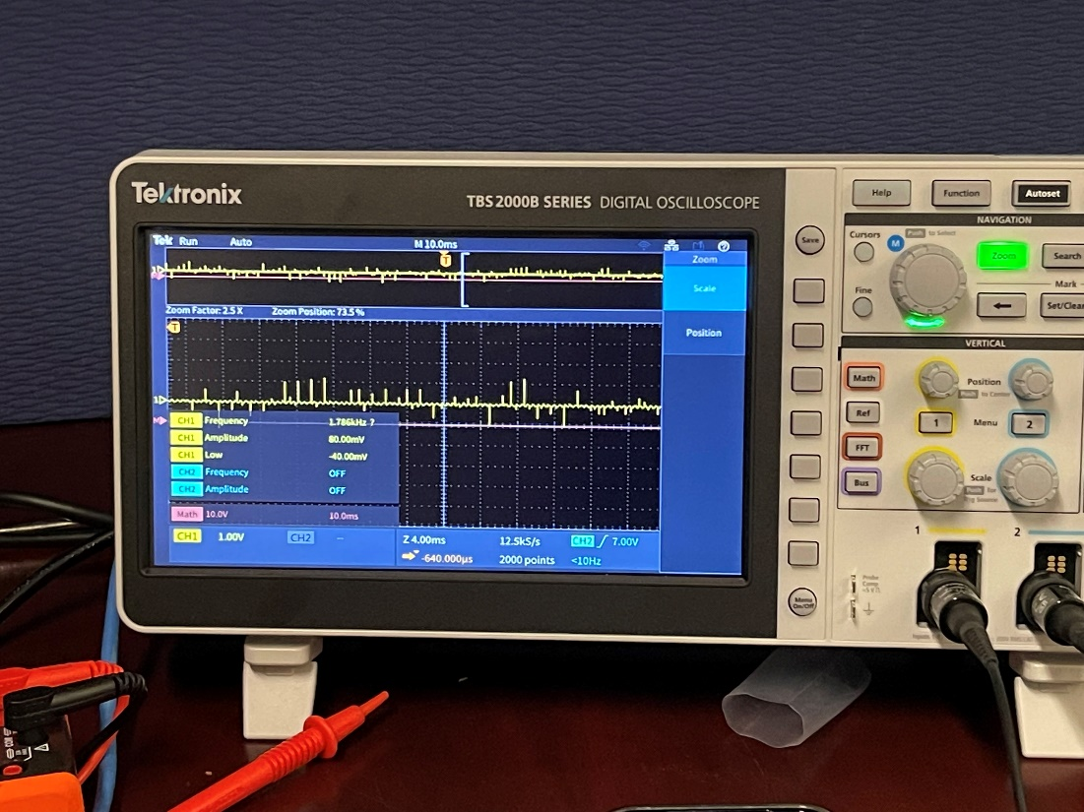

Figure 6: Signal to be injected into adversarial coil

